建議寫作題目內容：
(一)、中級英語寫作能力測驗Form A
1、中譯英：小時候，我和鄰居John同校。那時我們常一起打籃球，度過許多快樂時光。畢業以後，他和家人移居到國外。從此我們就失去連絡了。
2、英文作文：請依下面所提供的圖片及文字提示寫一篇英文作文，長度約一百二十字(8至12個句子)。作文可以是一個完整的段落，也可以分成兩段，請書寫在「寫作能力測驗答案紙」標示的位置上。評分重點包括內容、組織、文法、用字遣詞、標點符號、大小寫。
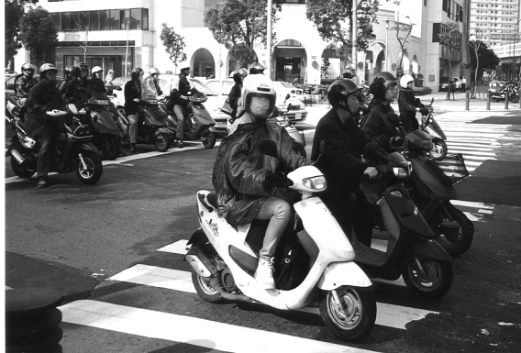
提示：
臺灣的機車數量很多。許多家庭擁有一部以上的機車，每天上班、上學都用機車代步。你認為在臺灣機車這麼普遍的原因何在？請說明你的看法。

(二)、中級英語寫作能力測驗Form B
1、中譯英：許多人不知如何增強英文寫作能力。其實多閱讀好文章對增強你的(英文寫作)能力非常有幫助。 此外，你可以嘗試用英文寫日記，甚至結交外國筆友。 總之，只有靠不斷地練習，你的寫作能力才會進步。
2、英文作文：請用約一百二十字(8至12個句子)完成以下的故事。寫作能力測驗的主題是 An Embarrassing Situation。請將完成的故事書寫在「寫作能力測驗答案紙」標示的位置上。評分重點包括內容、組織、文法、用字遣詞、標點符號、大小寫。
Yesterday was Peter's birthday. To celebrate, he invited some of his friends to have lunch with him at his favorite restaurant. Everyone had a good time. When they finished eating, Peter went to the counter to pay the bill. But when he looked in his wallet, he found that he had no money. …
(三)、中級英語寫作能力測驗Form C
1、中譯英：上個週末我和父親到河邊釣魚。在中午的時候，我們突然聽到有人大喊：「救命！」原來是有個小女孩掉到河裡去了。幸好有兩位年輕人及時把小女孩救了起來。雖然小女孩受了一點傷，但並沒有大礙。
2、英文作文：請依下面所提供的文字提示寫一封約一百二十字(8至12個句子)的英文信。信可以是一個完整的段落，也可以分成兩段，請書寫在「寫作能力測驗答案紙」標示的位置上。評分重點包括內容、組織、文法、用字遣詞、標點符號、大小寫。
提示：
(1)、上個月志中的朋友Peter和Susan邀請他到他們位於花蓮的家中住了一星期。在這一星期中，他們一起做了許多事情。現在，請你以志中的身份擬一封信給他們，謝謝他們的邀請，並告訴他們在花蓮作客時，令你印象深刻的事情。另外，不要忘記邀請Peter和Susan近期內到你位於台中的家中拜訪
(2)、信的上下款應依下列方式寫出。
December 20, 1998

Dear Peter and Susan,
_________________________________________________________________________________________________________________________________________
.
.
.
___________________________________________________________________________________________
Sincerely,
Chih-chung
(四)、中高級英語寫作能力測驗Form A
1、Part I: Chinese-English Translation：隨身聽最大的好處就是讓人可以隨時隨地聽音樂和廣播節目。無論在慢跑或等公車時，你如果覺得無聊便可以聽音樂以消磨時間。甚至想開大音量，也不會影響他人。但是有的醫生卻開始擔心，如果養成長時間聽隨身聽的習慣，聽力受損的人會越來越多。
2、Part II: Guided Writing: Write a letter of 150-180 words in an appropriate style according to the following instructions. Write your answer on the Writing Test Answer Sheet.
Leading English Magazine Has the Following Positions Open
- reporter - secretary
- editor - computer programmer
- translator
Interested candidates please send resume and cover letter to:
Formosa Features Magazine
36 Sanmin Road
Yungho City, Taipei
Fax: (02)2345-9876
E-mail: formosa1@rocnet.net
You are Kevin C. Liu. You notice the above advertisement in the newspaper, and you are interested in one of the positions. Write a letter of 150-180 words in response to the advertisement. In your letter you should first introduce yourself and then provide detailed information regarding the following:
- 1. which position you are interested in
2. why you are interested in the position
3. why you feel you are qualified for the position
4. your expected salary
5. when you could start
Kevin C. Liu
No. 20 Dali St., 3F
Chungho, Taipei

April 3, 2000

Formosa Features Magazine
36 Sanmin Road
Yungho City, Taipei

Dear Sir/Madam:
______________________________________________________________________________________________________________________________________________________________

Sincerely,
Kevin C. Liu
(五)、中高級英語寫作能力測驗Form B
1、Part I: Chinese-English Translation:從前的人出遠門既不方便又危險。通常要花好幾天或甚至幾個月的時間才能抵達目的地。此外，在旅途中也很容易發生意外。飛機的發明不僅縮短了旅行時間，也提高了安全性。科技發展如此快速，看來到月球旅行，不會是不可能實現的夢想。
2、Part II: Guided Writing: Write an essay of 150-180 words in an appropriate style based on the following charts. Write your answer on the Writing Test Answer Sheet. The bar graph below shows the number of traffic accidents which occurred on a particular day in 1999 in Taipei. Write an essay of 150-180 words according to the following instructions:
- Summarize the information shown in the graph below.
- Discuss some possible reasons for the different numbers of accidents.
- Suggest some ways in which the number of accidents might be reduced.
(六)、中高級英語寫作能力測驗Form C
1、Part I: Chinese-English Translation: 我的表妹從大一就一直住在學校宿舍。當初她選擇住校的主要原因是以安全方便為考量，但是現在卻對宿舍的一些規定感到苦惱。有一次她因為在實驗室做化學實驗做到半夜，而被鎖在宿舍大門外。由於這件事情，她正考慮下學期搬出宿舍。
2、Part II: Guided Writing: Write an essay of 150-180 words in an appropriate style according to the following main topic. Write your answer on the Writing Test Answer Sheet. Topic: Cell Phone Use in Taiwan. It has been reported that the number of cell phone users in Taiwan now exceeds 10 million people, nearly half the population. In terms of cell phone use in Asia, Taiwan ranks behind only Hong Kong and ahead of Singapore and Japan. Please discuss this topic regarding the use of cell phones in Taiwan and provide reasons to explain the rapidly increasing popularity of cell phones in Taiwan.

